neural network classifier in python using Iris dataset (jupyter)

[1]Copy the code from python file to jupyter..

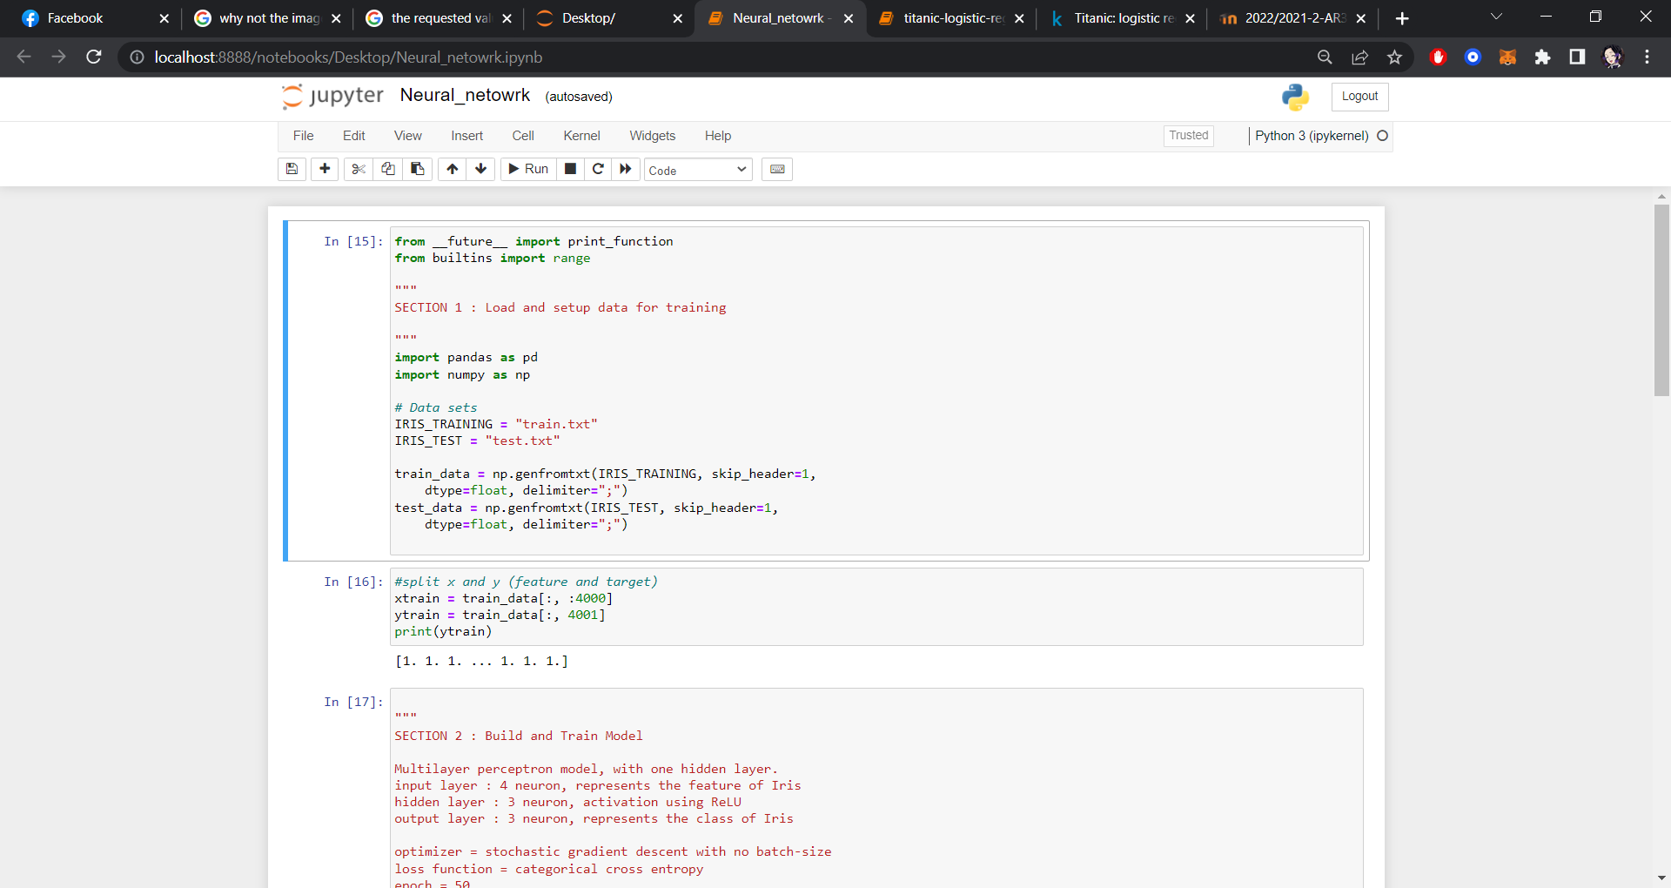

[2]Change lines of code as follow…

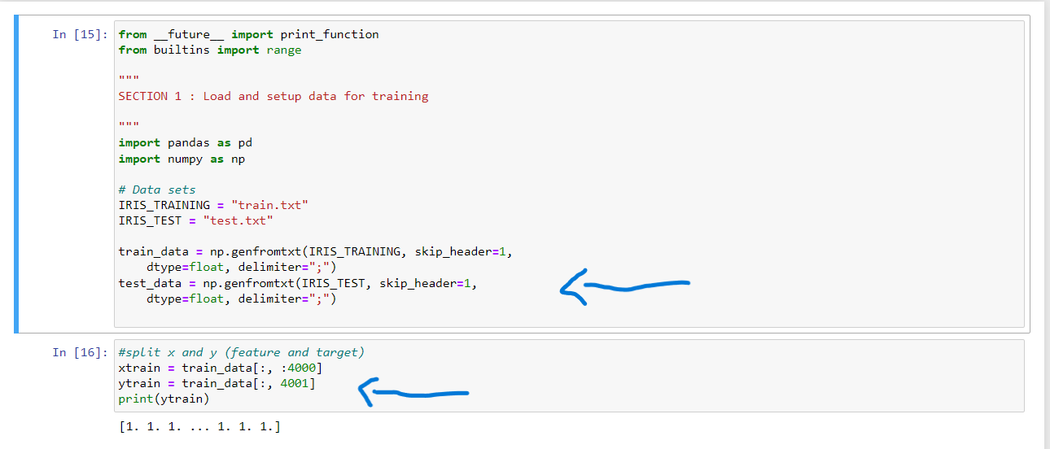

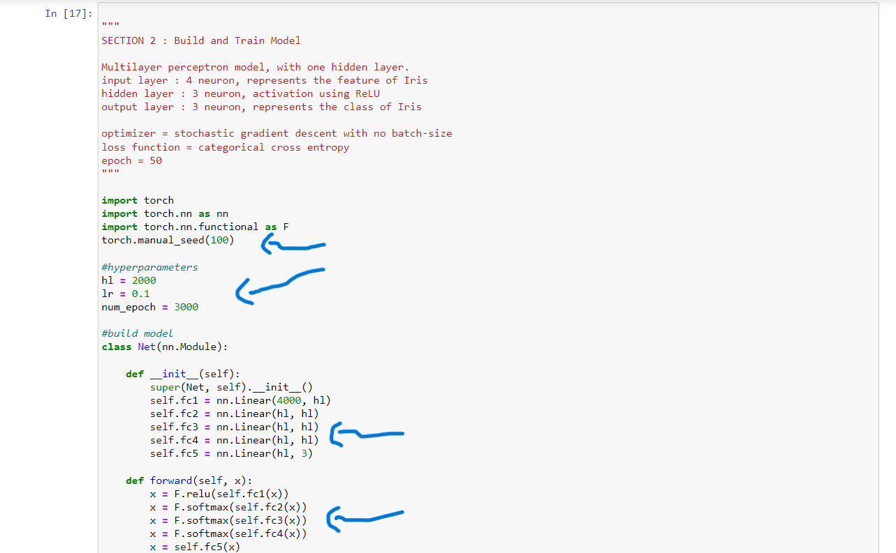

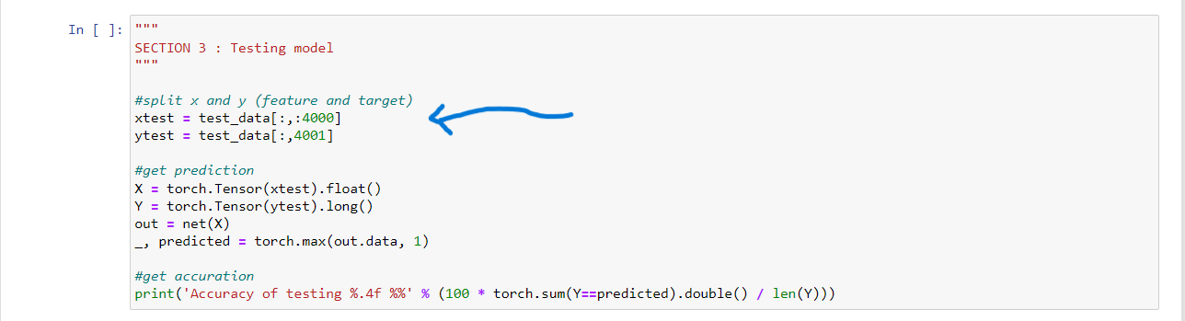[3]Run the cod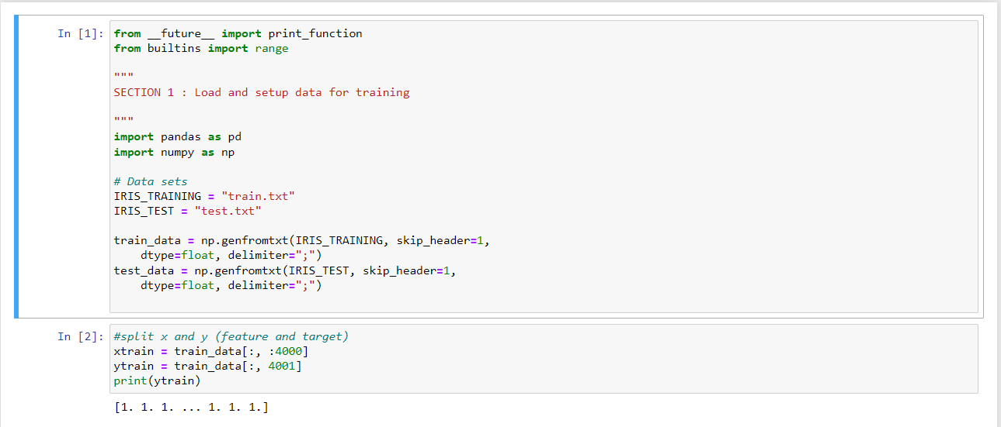

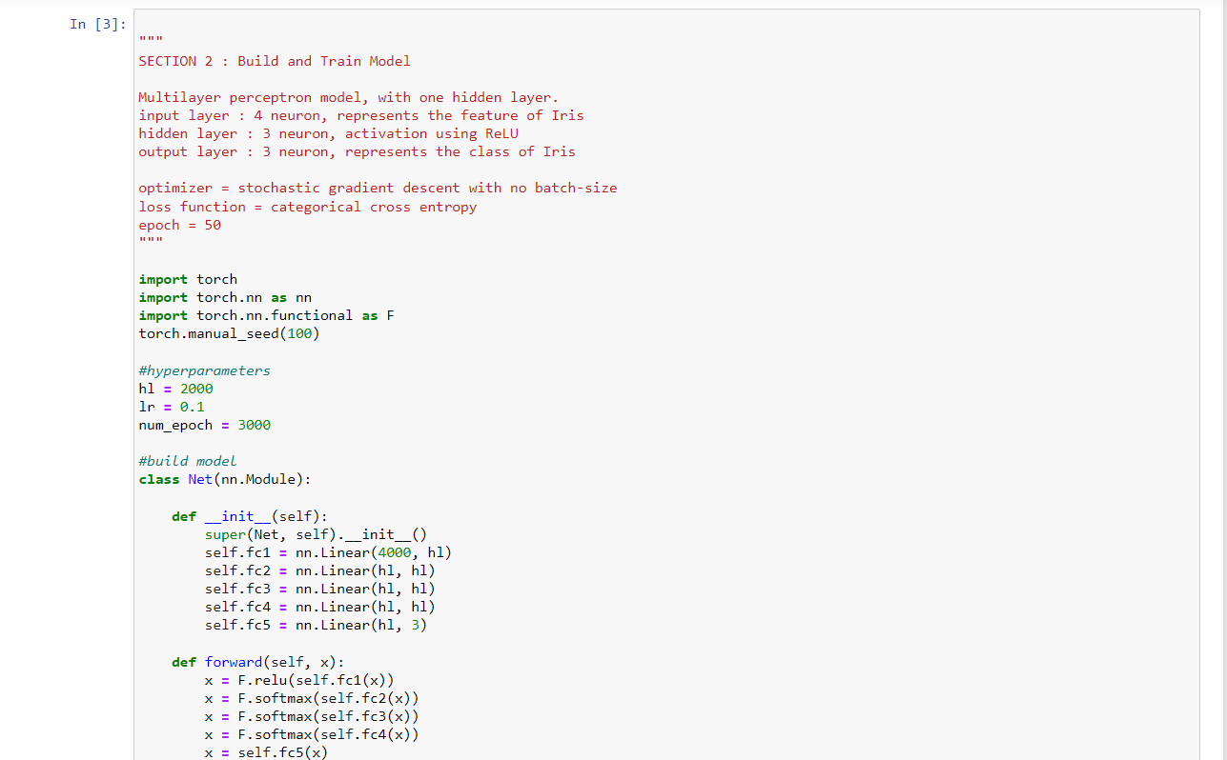

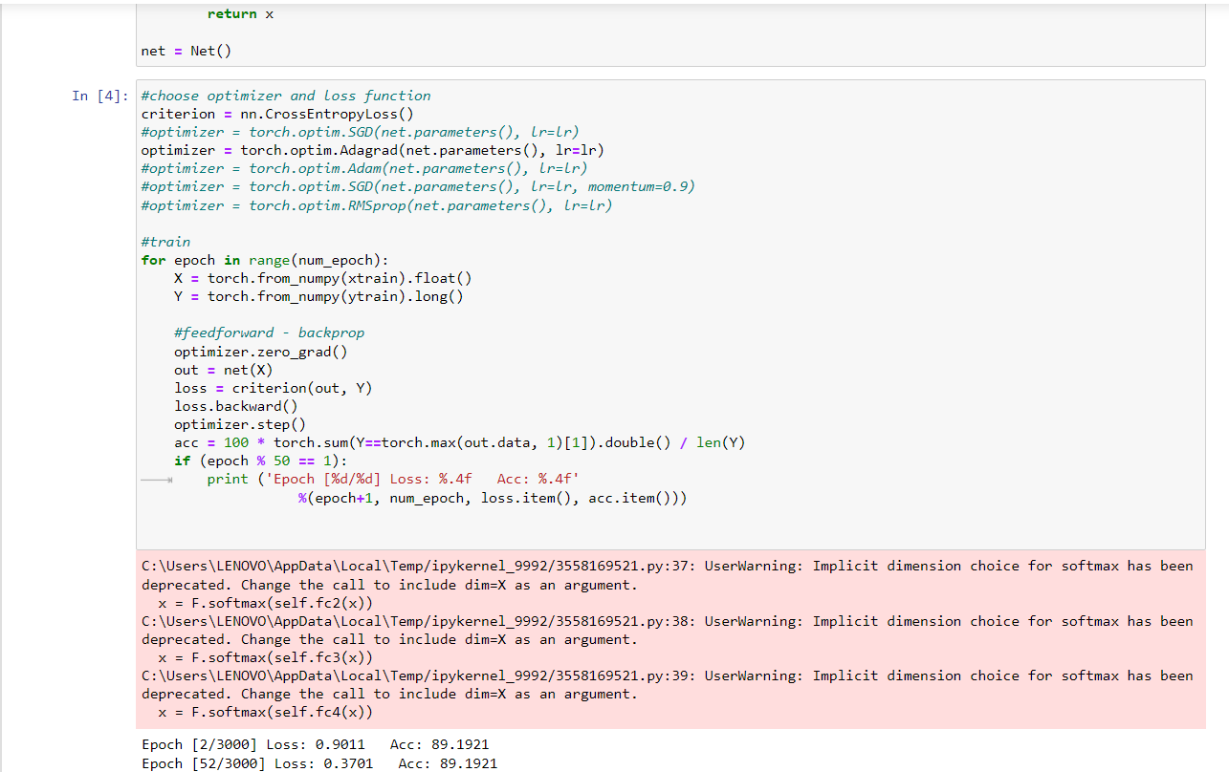

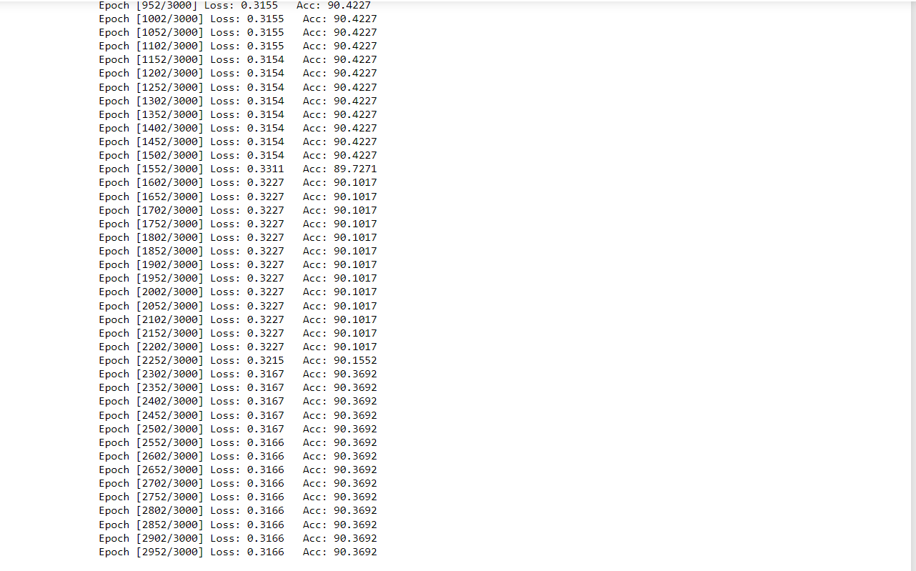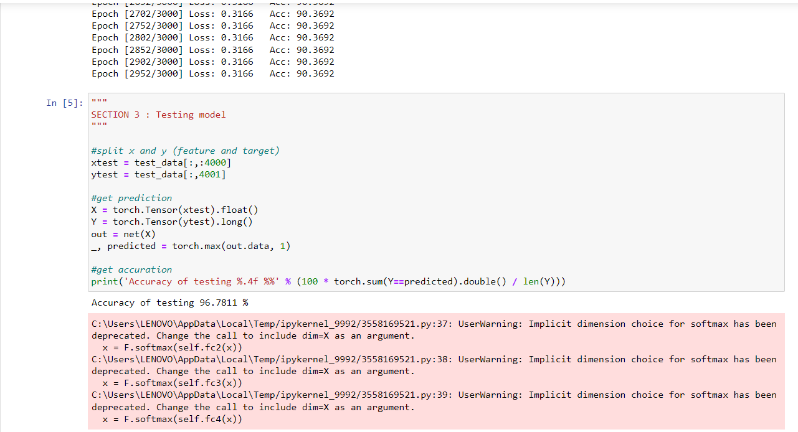

[1] there is a table that illustrate different results by changing the hyperparameters and optimizers in ReadMe.txt file.

[2] the number of input neuron is 4000.

[3]Note: I tried a lot of changing in the hyperparameters and optimizers more than in the table.

### name : Ramah Hashem Madi

### ID NO.: 31909303044